Infinite series
Example 1
We say the infinite seriesconverges. What does this mean?
As we add up more and more terms ...
...
the total gets bigger and bigger but never exceeds a certain number (in this case, 1)
Example 2
We say the infinite seriesdiverges. What does this mean?
As we add up more and more terms ...
...
the total gets bigger and bigger and will eventually exceed any number.
Proof

The value of each bracket on the RHS is greater than
So:

So the series will eventually exceed any number.

Here is another proof (by contradiction)
Assume the series converges to some finite number
So:
So:
So:
So:
So:
Contradiction.

The series:

is called the harmonic series. It diverges but very slowly. The sum of the first billion terms is only about 21.3
Example 3
Compare the series:with the series:
The terms in the second series are equal to or smaller than the corresponding terms in the first series. We know the first series converges so the second series must converge.
Example 4
Compare the series:with the series:
The terms in the second series are equal to or larger than the corresponding terms in the first series.
We know the first series diverges so the second series must diverge.
Example 5
Look at this series:
Show that:for any
Show that:
Show that:
Show that:
So the series converges.

If you study maths at a higher level you will learn how to manage infinite series properly.
In the meantime we can have some fun ...

Example 6
Evaluate:
Now:
So:
But:
So:
Example 7
Evaluate:
1st attempt:
2nd attempt:
3rd attempt:
Example 8
Evaluate:
Now:
So:
So:
Example 9
Evaluate:
1st attempt:
2nd attempt:
3rd attempt:
Example 10
and
So:
So:
But:
So:
Example 11
Now: it’s a geometric series
So if we sub inwe get:
And if we sub inwe get:
Example 12
Now: it’s a geometric series
If we differentiate we get:
So if we sub inwe get:
Example 13
Now: it’s a geometric series
So if we sub inwe get:
Example 14
We know: see example 14
We know: see example 13
Let:
So:
So:
So:
So:butso
Hence:
Example 15
Consider the series:

etc
The terms on the LHS sum to:

The terms on the RHS all cancel.
So
Every infinite series sums to zero. We should have done this example first!

If you know about integration ...
Example
Here is the graph
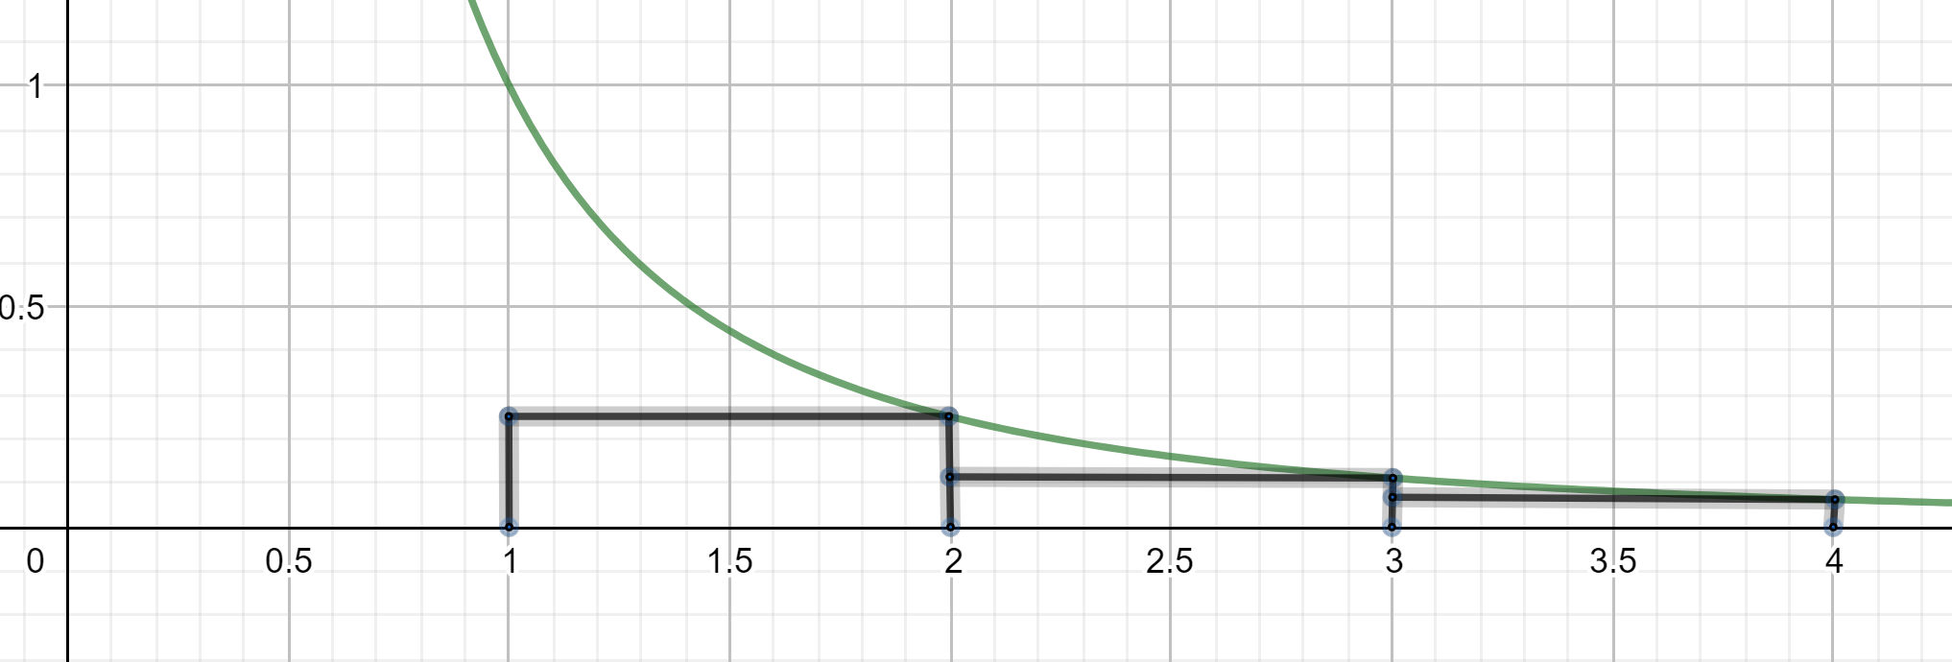

The diagram shows blocks betweenand

The area of the blocks is:
The area under the graph is:
The area of the blocks is less than the area under the graph.
So:
So:converges.
Example
Here is the graph
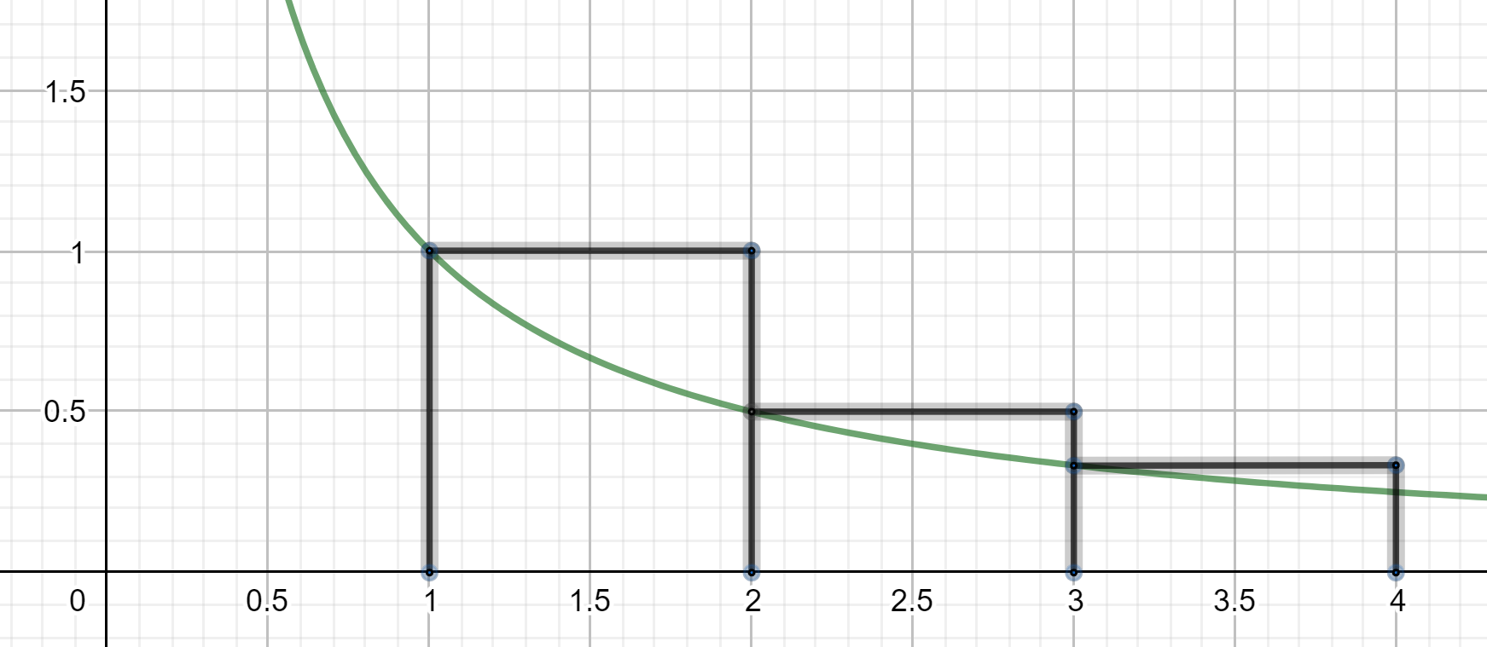
The area of the blocks is:
The area under the graph is:
The area of the blocks is greater than the area under the graph.
So:diverges.

